**Estimation of business Expenses**

Introduction

It takes money to make money. Companies exist primarily to make money, but in due process, they incur various business expenses crucial to their existence. Running a business requires a dedicated workforce, strong leadership, business acumen, and, most importantly, a constant influx of funds.

All expenses incurred for business purposes by an organization are business expenses. They are optional, regular, and incidental costs that fund a company’s survival, growth, and everyday functioning. Every spending that helps sustain the business can be classified as a business expense, from fixed expenses like plant and machinery to trivial expenses like client gifts.

Types of business expenses based on the frequency

All money spent for business use is a business expense. Classification of these expenses is essential to important finance functions like accounting, budgeting, cash flow forecasting. Based on the frequency and occurrence, you can classify business expenses as follows.

1. Fixed expenses

These costs are recurring and do not change every month. They are predictable expenses. While they can change or increase with time, they remain the same during a specific predetermined period. Examples are base salaries, office rent, mortgages, etc.

2. Variable expenses

These expenses differ monthly, and their value depends on certain factors. For example, the sales commission given to the sales personnel is a variable expense. It depends on the number of sales made by the team.

The higher the sales figure, the higher the expense would be. Other variable expenses are electricity, inventory and storage, shipping, and credit card fees.

3. Recurring expenses

These expenses repeat throughout the month. They are not predictable and rarely depend on other factors to be incurred. Some regular expenses are staff compensation, administrative costs, subscriptions, memberships, communication costs, etc.

4. Non-recurring expenses

These expenses are incurred once or twice a year. Examples of non-recurring costs include mergers and acquisitions, lawsuit settlement fees, purchase of new equipment or real estate, etc.

2. Problem Definition & Design thinking

EMPATHY MAP

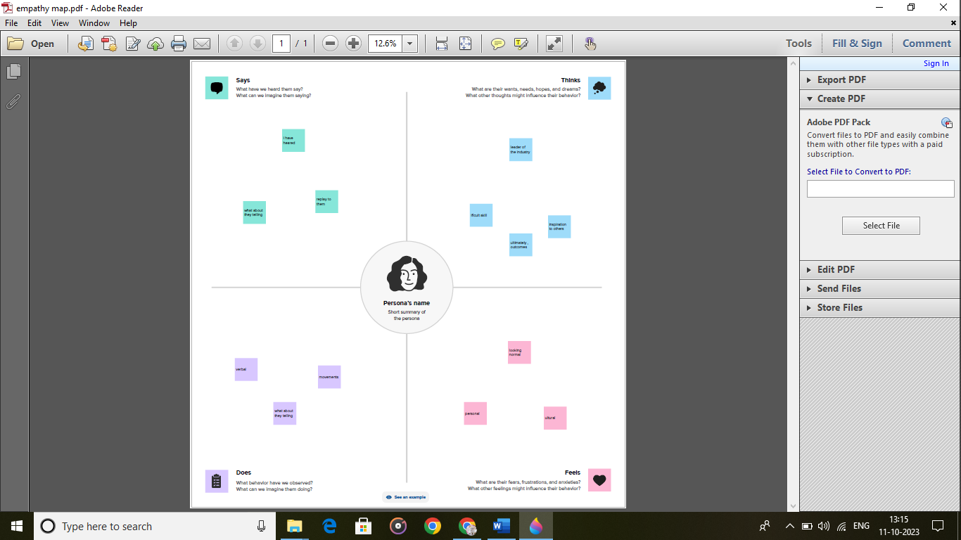

BRAIN STORM AND IDEA PRIORITIZATION

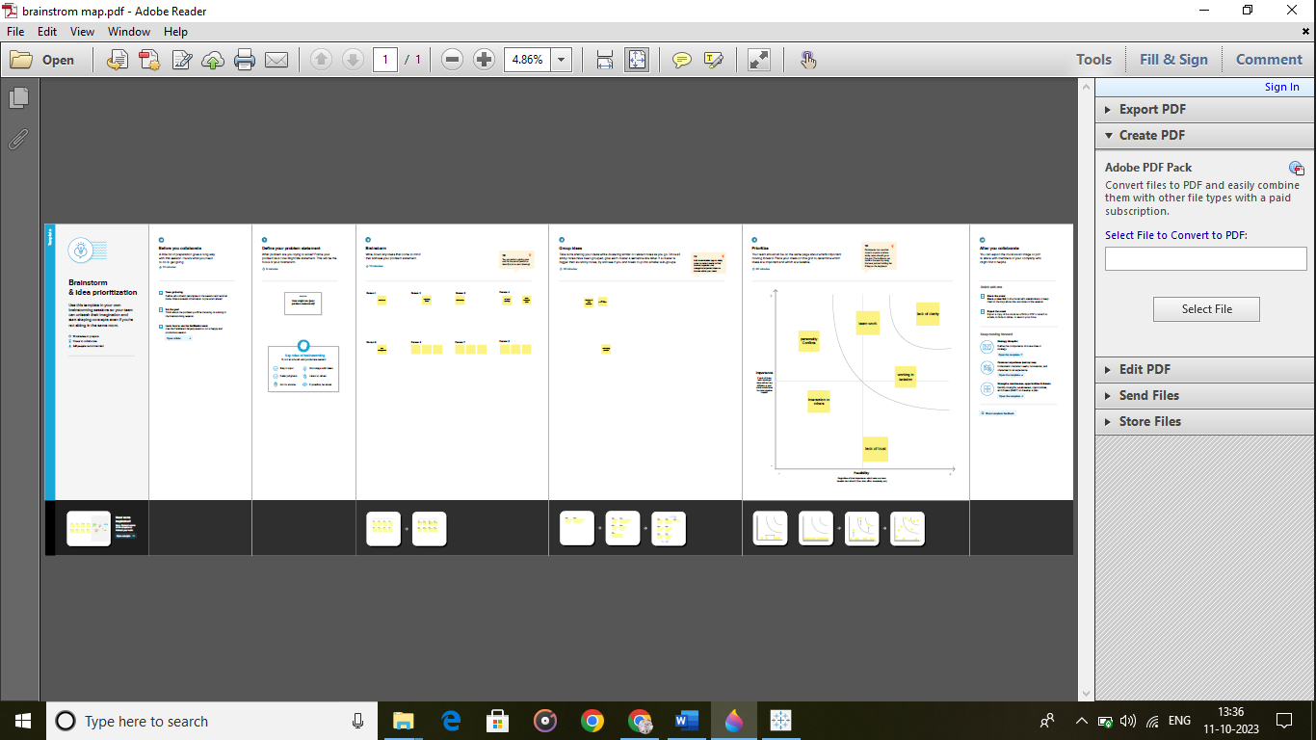

3 RESULTS

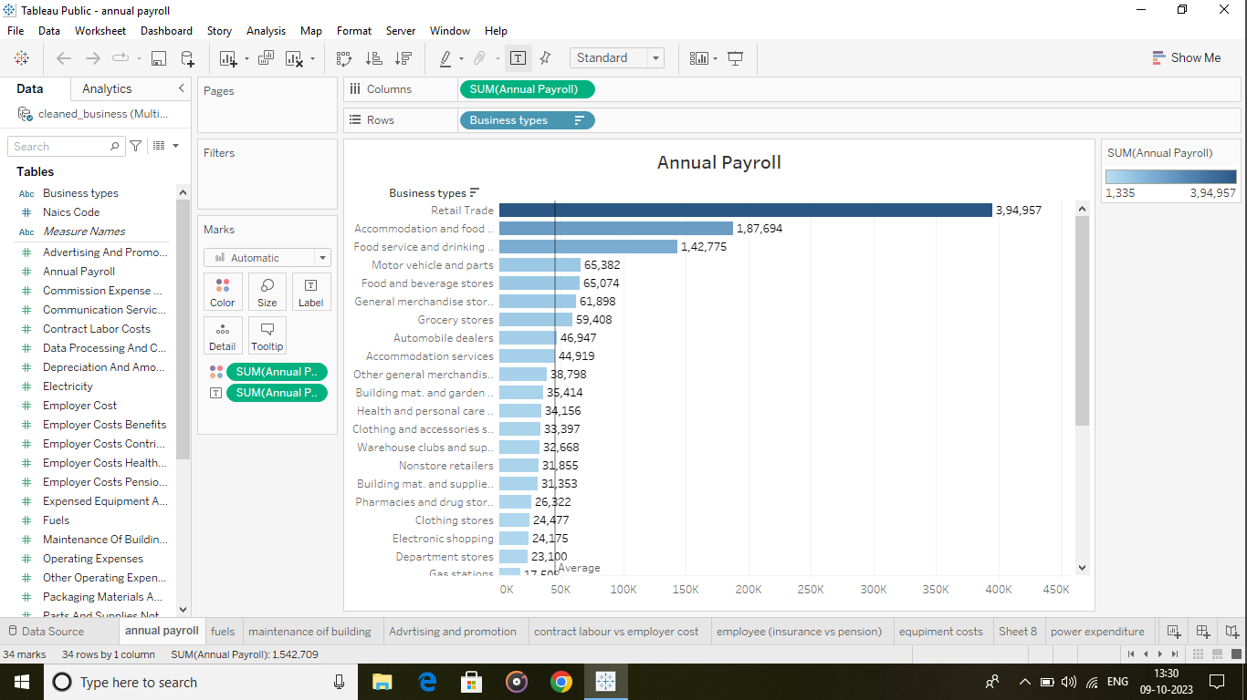

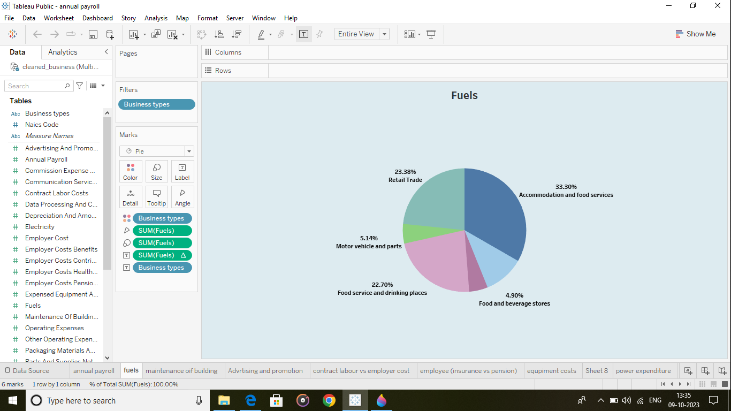

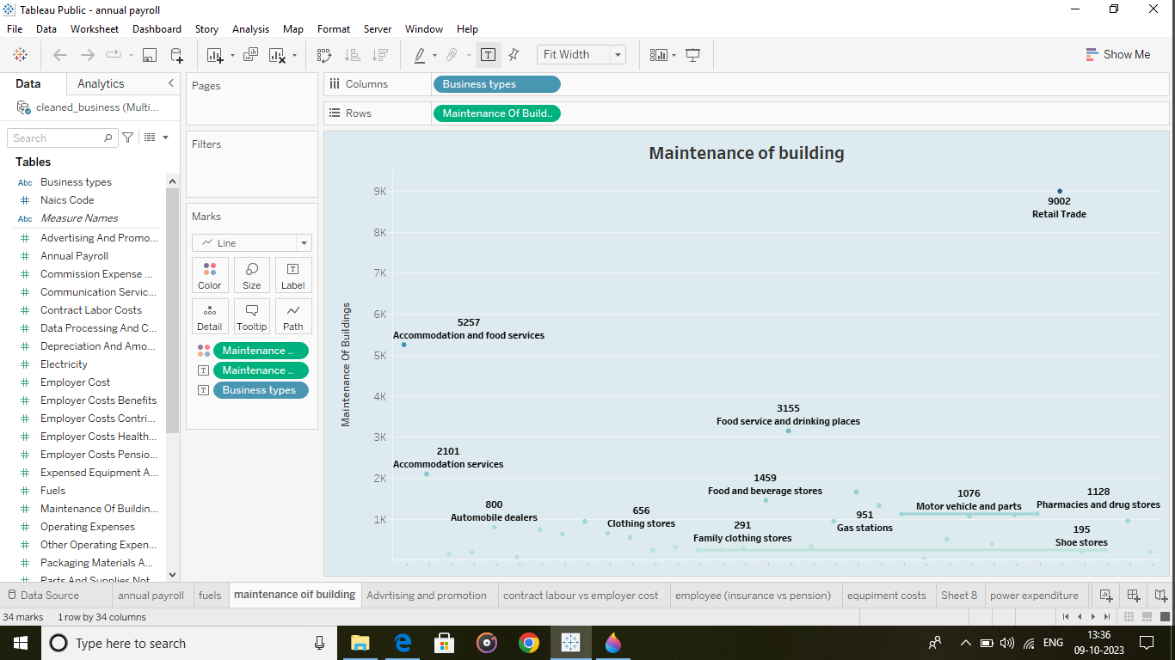

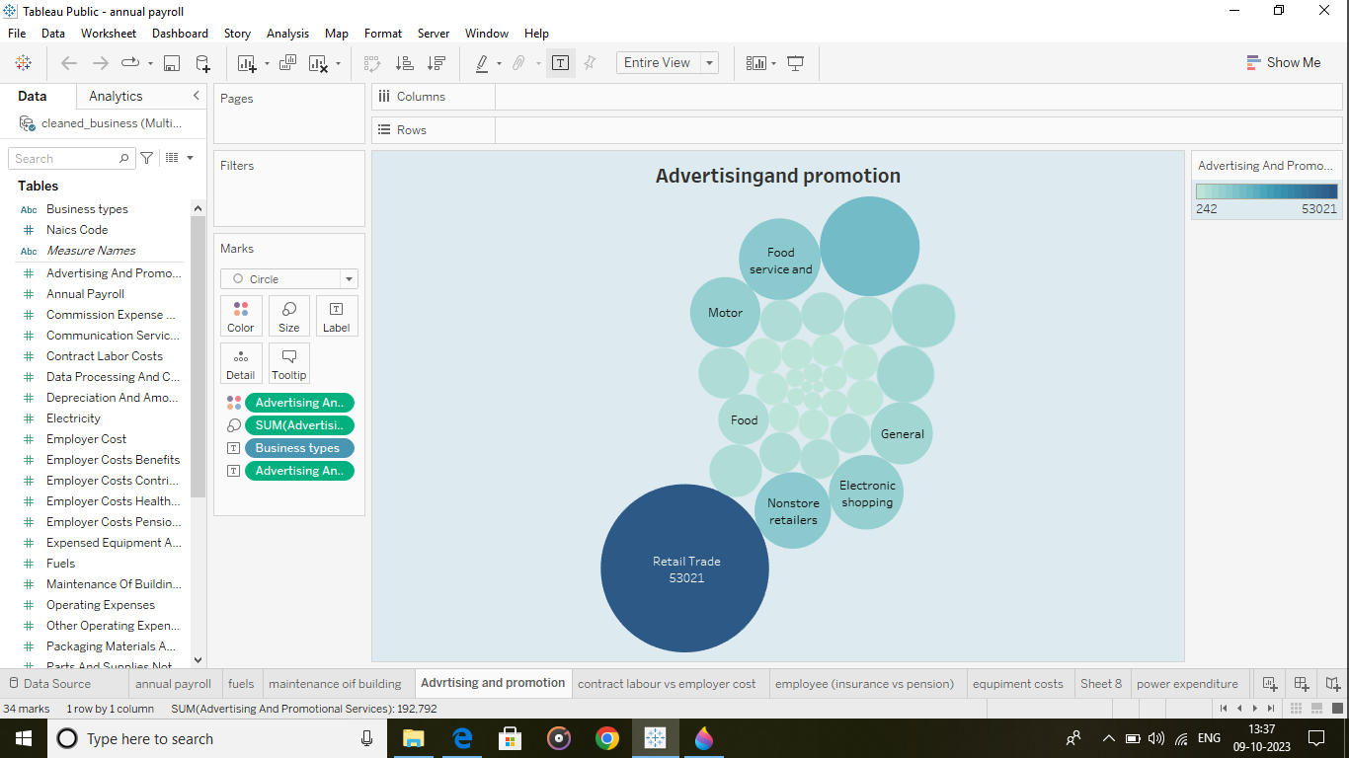

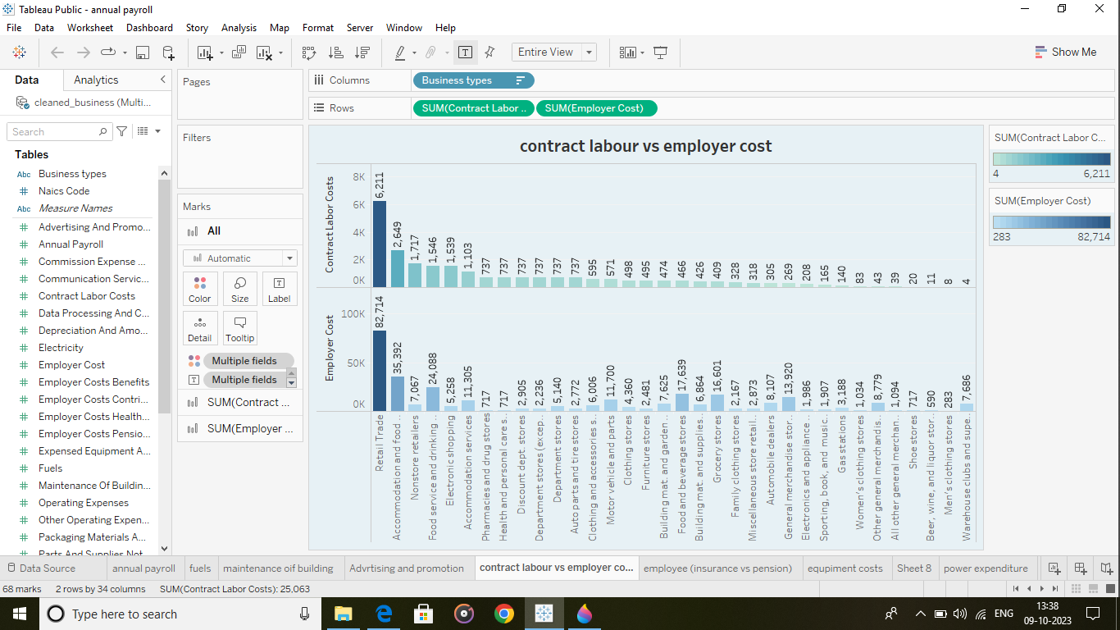

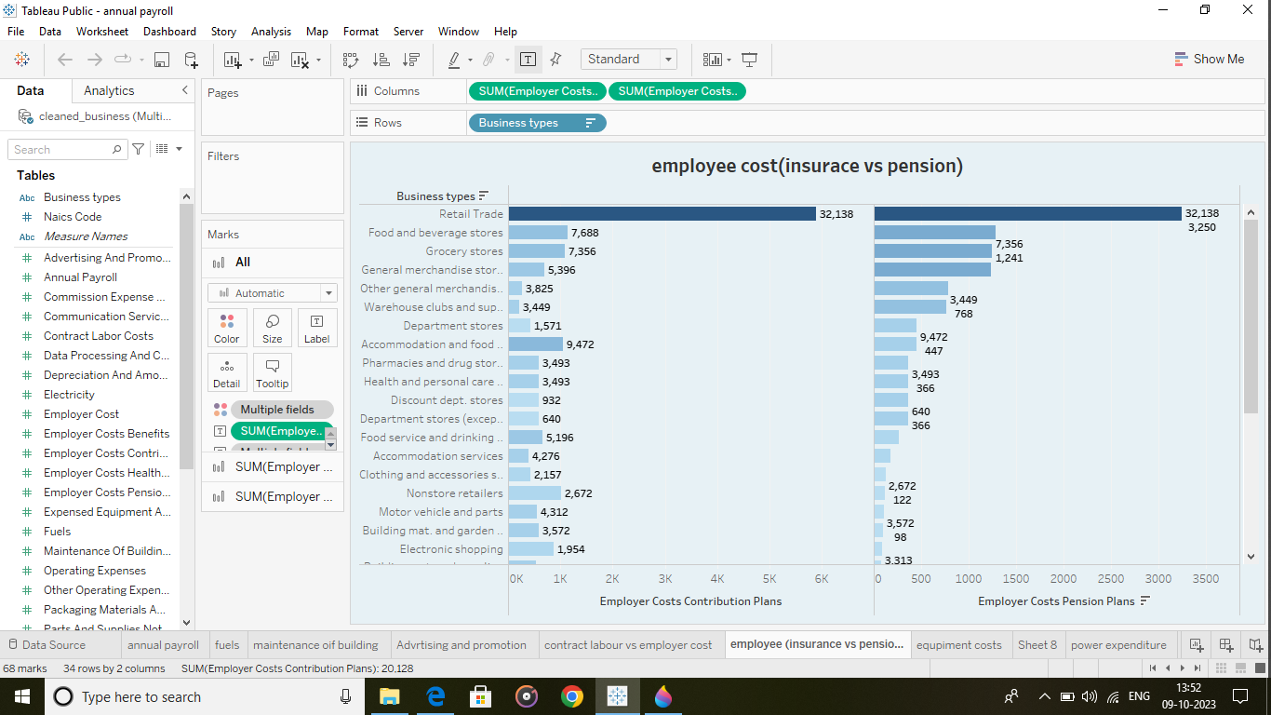

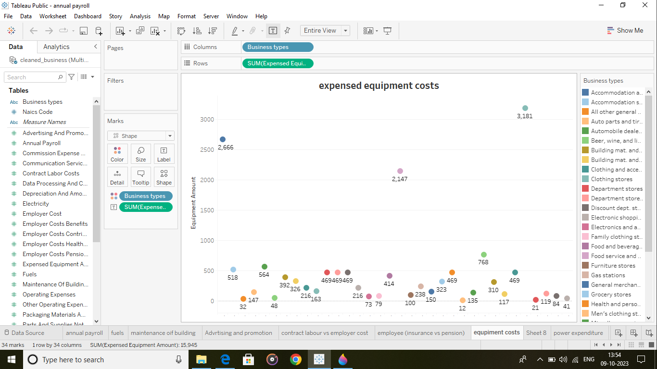

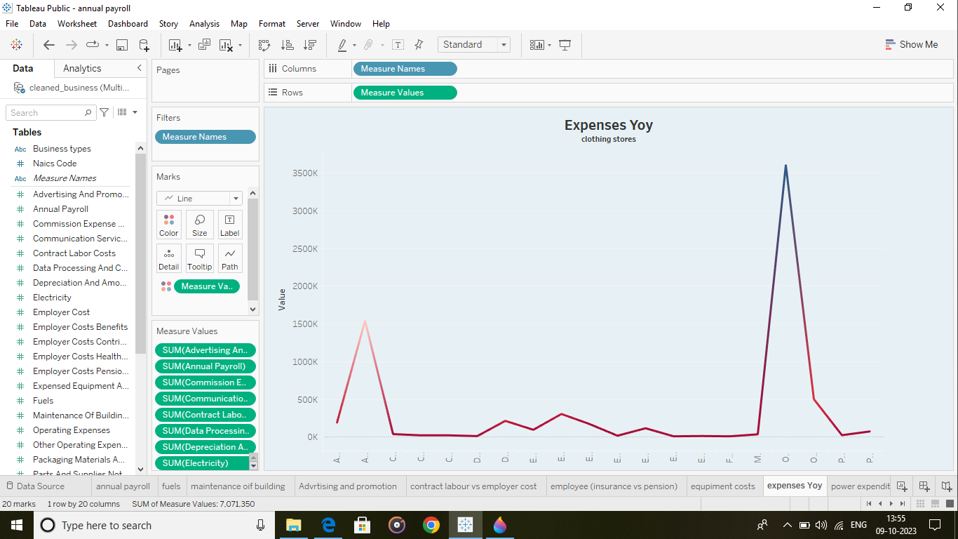

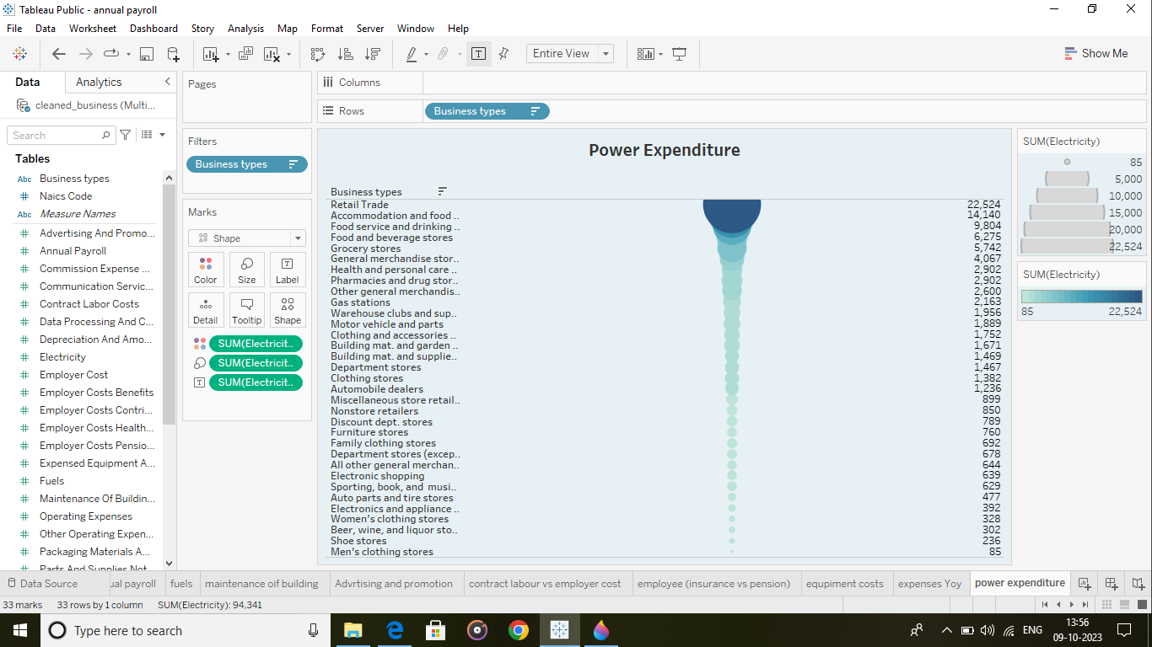

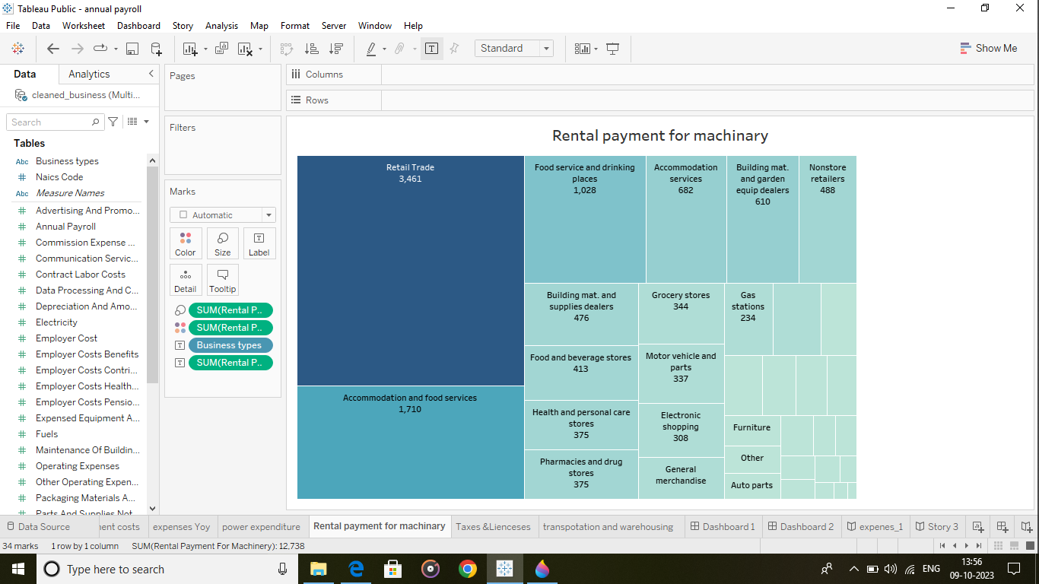

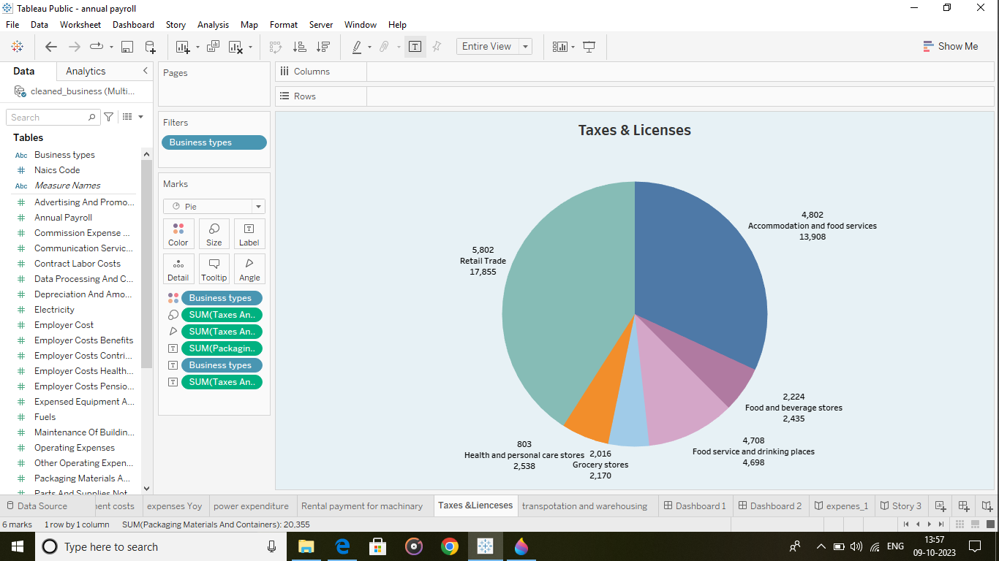

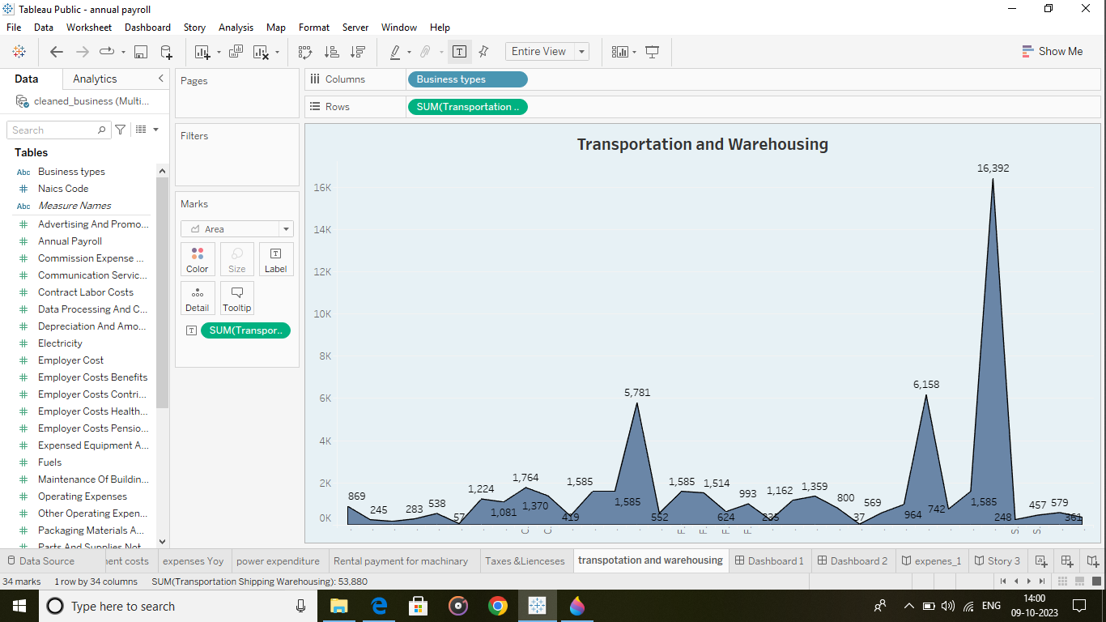

Dashboard 1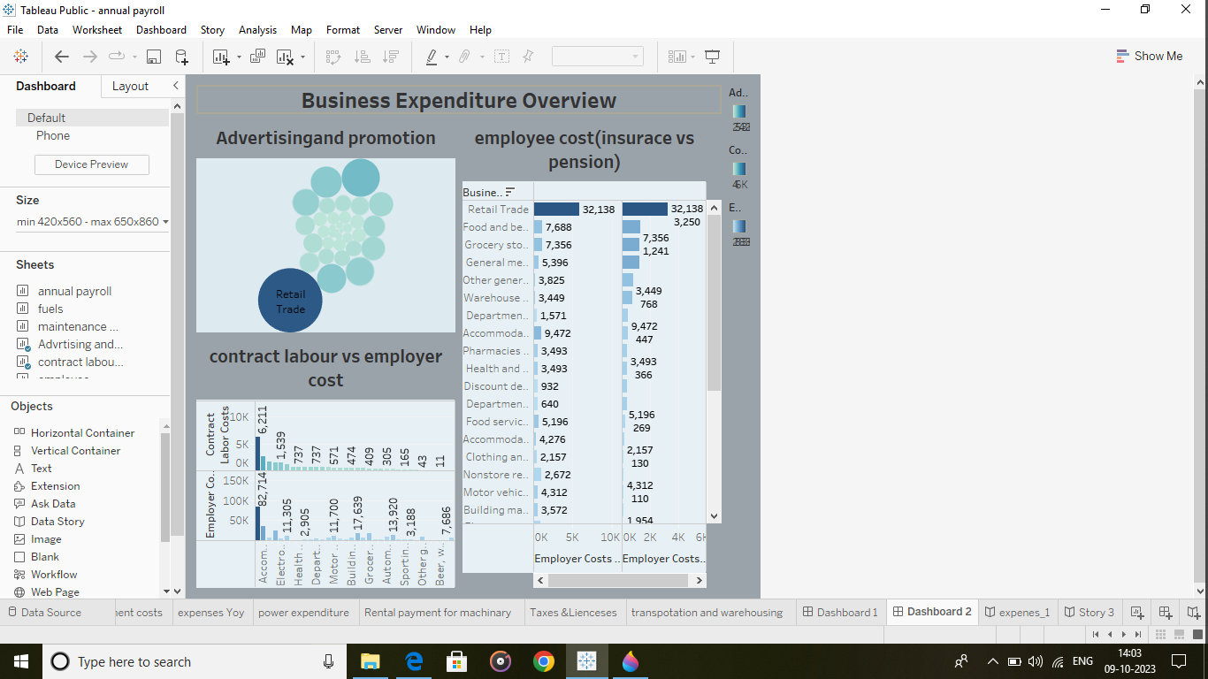Dashboard 2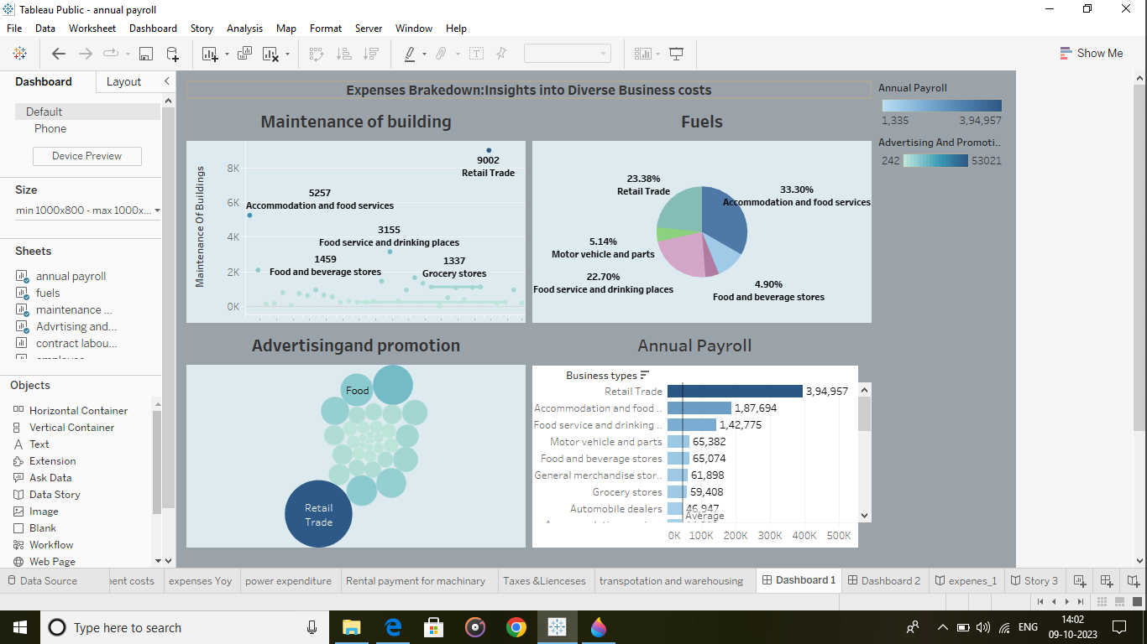

Story 1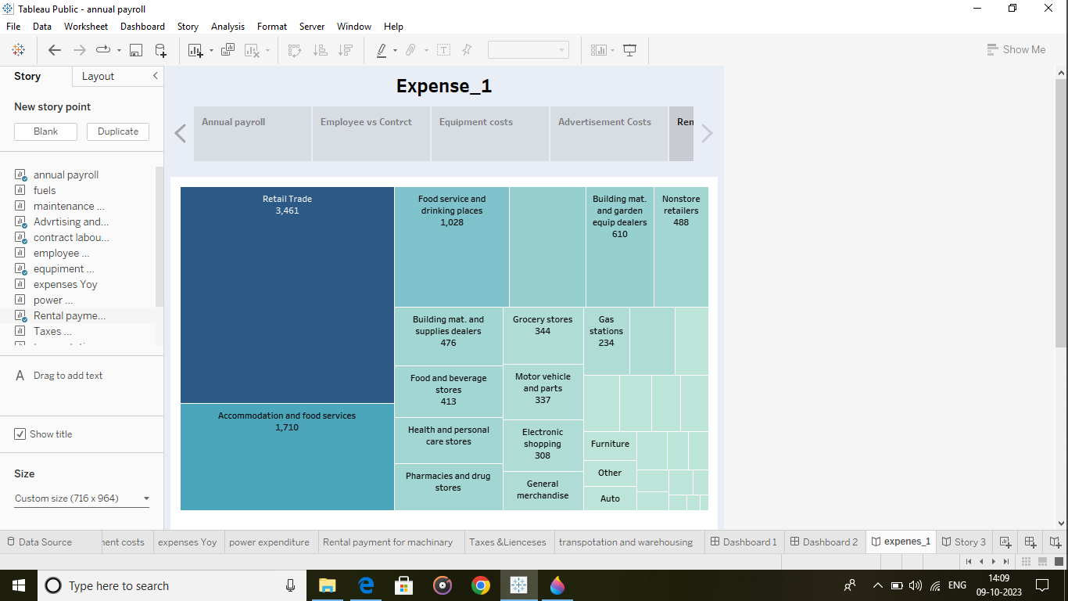

Story 2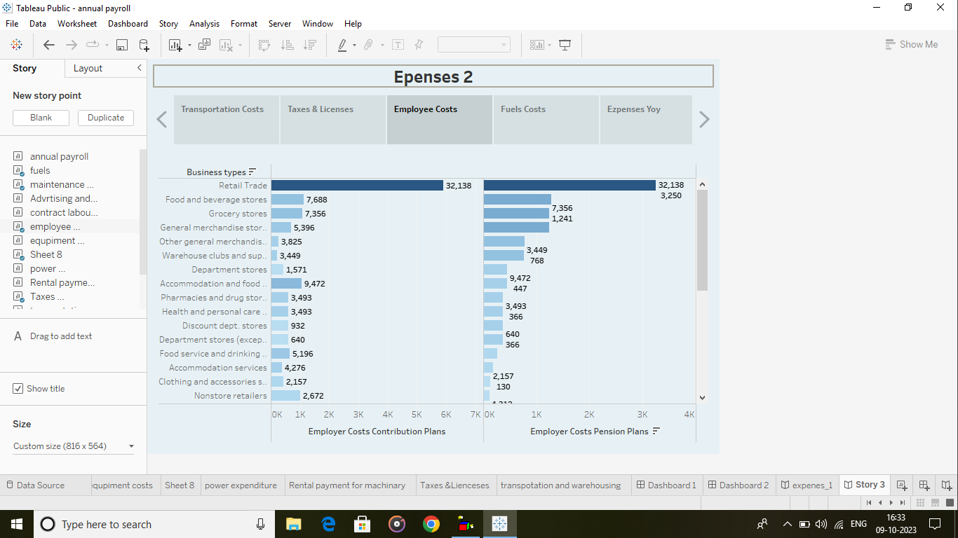

Types of business expenses based on function

1. Operating expenses

[Operating expenses](https://happay.com/blog/operating-expenses/) are used to pay for the day-to-day functioning of a business. All direct business-related costs facilitating the production and manufacturing of goods can be categorized as operating expenses. Administrative, compensation, sales, and marketing-related costs are all operating expenses.

2. Non-operating expenses

[z](https://blog.happay.com/non-operating-expenses/) fund additional functions required to sustain a business’s financial health and operations. They include one-time expenses like lawsuit settlements, inventory write-offs, and regular expenses like interest payments and depreciation. These costs are not used to facilitate the core business operations, nor do they pay for the production of goods.

3. Capital expenses

[Capital expenses](https://happay.com/blog/capital-expenditure-capex/) are used to fund the business’s purchase, management, modification, or maintenance of capital assets. Examples of capital expenditures are money spent on building buildings, upgradation of machinery, digital infrastructure, company vehicles, etc.

4. Cost of goods sold or COGS

The cost of goods sold, or COGS, is the summation of all the expenses that directly fund the conception and manufacturing of the final business offerings. They include the cost of raw materials, salaries of employees directly involved in producing goods, machinery, factory, packing, etc.

5. Incidental expenses

[Incidental expenses](https://happay.com/blog/incidental-expenses/) are unplanned and primarily unpredictable. They are mainly trivial expenses such as auxiliary costs during travel, like room service, baggage handling fees, entertainment expenses, staff tips, etc.

PURPOSE

Preparation for Sale

If you’re interested in selling your company or buying another, a the best valuation techniques provide a detailed account of historical revenue, expense and profit numbers, a list of tangible and intangible assets, a breakdown of liabilities and qualitative information on aspects of the company such as goodwill and key employees.

Using this information, you can project what profits the company is likely to earn during the coming years and help determine a fair price for the business, explains the  [Business Buyer Resource Center](https://www.diomo.com/valuing-a-business.html).

Partnership Dissolution Data

Just because partners decide to part ways doesn’t mean the business must close. One or more partners might decide to buy out the others, and a valuation will help them do that. The partners might wish to sell the business to a third party. If one partner dies, his heirs will want to know how much they should receive as his share of the business. This is one purpose of valuation efforts.

Helps Secure Investments

If you’d like to expand or obtain capital during a rough patch, an investor might be your only option. In addition to receiving his original investment back, an investor might want an ongoing percentage of the profits, part ownership of the company or the right to open another office or store under the same name. Having a detailed business valuation will help you make a stronger pitch when meeting with investors.

Loans and Factoring

Banks and other lenders make loans that require collateral called secured loans. For example, you might obtain a loan to buy a new machine to increase your production capacity by using your other machines as collateral. Business entities called factors lend you money against your receivables, purchasing them at a discount. Having an up-to-date business valuation makes it easy for potential lenders or factors to make an assessment.

Taxation and Legal Disputes

If heirs inherit or family members are gifted a business, they will want to reduce the taxes they pay by getting the lowest valuation possible. They will make an effort to point out problems and weaknesses a third-party evaluator or appraiser might not find. During a divorce, one party might want high valuation while the other will want the lowest possible valuation.

Application

**Business valuation** is a process and a set of procedures used to estimate the [economic value](https://en.wikipedia.org/wiki/Valuation_(finance)) of an owner's interest in a [business](https://en.wikipedia.org/wiki/Business). Here [various valuation techniques](https://en.wikipedia.org/wiki/Valuation_(finance)) are used by financial market participants to determine the price they are willing to pay or receive to effect a sale of the business. In addition to estimating the selling price of a business, the same valuation tools are often used by business appraisers to resolve disputes related to estate and gift taxation, divorce litigation, allocate business purchase price among business assets, establish a formula for estimating the value of partners' ownership interest for buy-sell agreements, and many other business and legal purposes such as in shareholders deadlock, divorce litigation and estate contest.

Conclusion

The Conclusion of Value is an estimate of the value of a business, business ownership interest, security, or intangible asset, arrived at by applying the valuation procedures appropriate for a valuation engagement.

Scope

**Scope**: Estimating focuses on specific, short-term tasks, while forecasting looks at broader, long-term trends and outcomes.

**Purpose**: Estimating guides resource allocation and task planning, while forecasting supports strategic planning and decision-making.

APPENDIX

<https://drive.google.com/file/d/121RYdL0o2SOZ9nFbYLZ05bdiuTmHJkq3/view?usp=drivesdk>